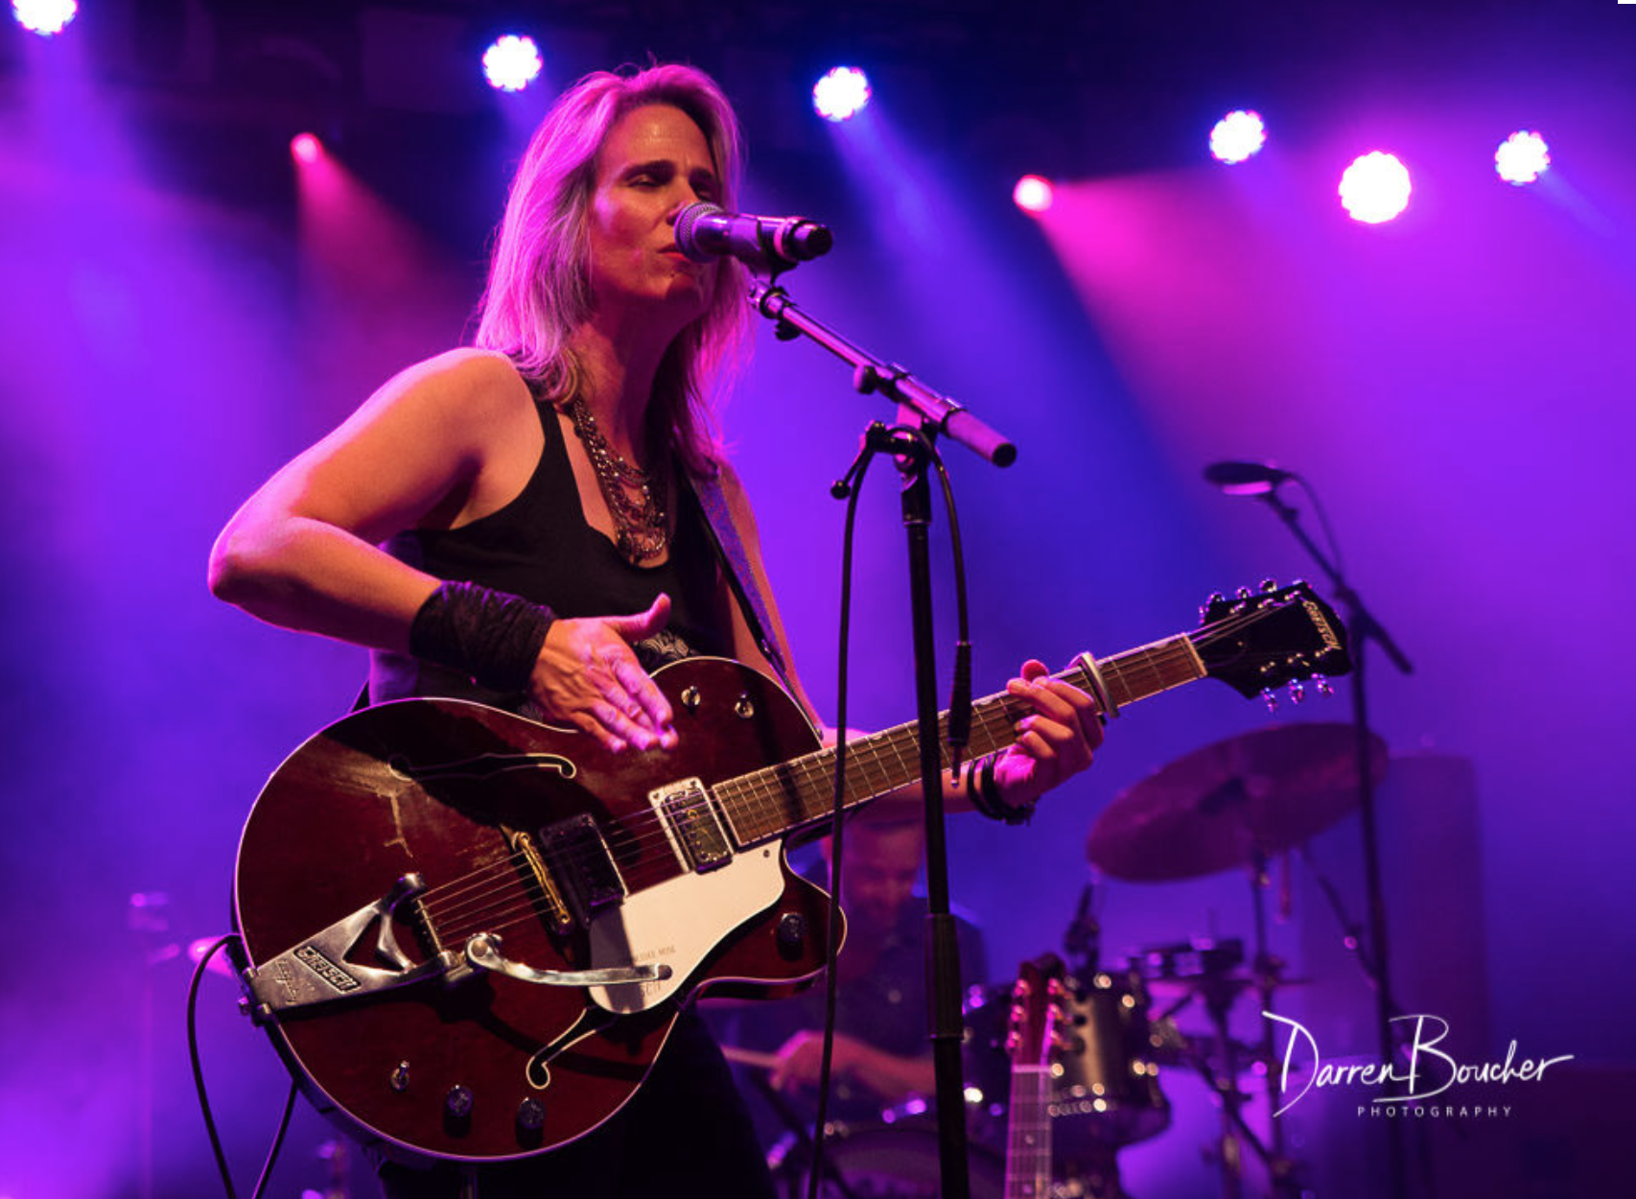
Too tough for folk and too blues influenced for country, LYNNE HANSON's brand of "porch music with a little red dirt" can turn on a dime from a sunshine, blue sky ballad to a full-on thunderstorm of gritty Americana swamp from one song to the next. She's known for her high-energy, roots guitar driven live performances, whether playing solo or with her band the Good Intentions. A closet stand-up comedian, Lynne often leaves the audience howling with laughter with her between-song-banter.

Lynne is a two-time Canadian Folk Music Award winner (2018 English Songwriter, Ensemble of the Year with The LYNNeS), a two-time Indie Acoustic Project Alt-Country album of the year winner (River of Sand 2014, Uneven Ground 2017), a past winner of the Colleen Peterson Songwriting Award, and a two-time finalist in the prestigious Kerrville New Folk competition in Texas.

Lynne has toured Canada, the US, Europe and the UK. She's toured the UK in support of Grammy nominated songwriters (Gretchen Peters, Steve Forbert), as well opening for guitar legend Albert Lee in the UK and Canada.

Lynne is currently working with Jim Bryson (The Weakerthans, Kathleen Edwards) on her seventh studio album to be released early 2020.

AWARDS
2019 Kerrville New Folk Finalist
2018 Canadian Folk Music Award with The LYNNeS
Winner: English Songwriter and Ensemble of the Year
Nominee: Contemporary Album, Producer, Vocal Group of the Year
2017 Indie Acoustic Project best Alt Country CD (Uneven Ground)
2015 2nd place finish The Indie International Songwriting Contest (This Too Shall Pass)
2014 Indie Acoustic Project best Alt Country CD (River of Sand)
2010 Colleen Peterson Songwriting Award
2009 Canadian Folk Music Award Nominee
2009 Kerrville New Folk Finalist
2008 Mountain Stage New Song Regional Finalist
2006 OCFF "Songs from the Heart" Blues Award
PRESS QUOTES
"[Lynne Hanson] seems headed for that revered territory inhabited by seasoned songwriters such as Nanci Griffith, Mary Chapin Carpenter, Mary Gauthier or Lucinda Williams." Barry Hammond – Penguin Eggs
"Somewhere in the heartlands, in a town called 'Americana USA,' nestles a particular variety of singer-songwriter. Someone who views a melodic sensibility through the bottom of a whiskey glass. Canadian songstress Lynne Hanson could run for mayor of that town." Trevor Raggatt - R2 Magazine (5 stars)

"A mesmeric collection of seven dark pieces, splendidly assembled ... the album in its recorded format is tantalizingly sitting there for you to make a valuable addition to your collection." - Three Chords and the Truth (UK)
SAMPLE PERFORMANCE QUOTES
"Thank You for the outstanding performance at our festival. I knew from the first note that I had hit a home-run hiring you, you were a joy to deal with and I will certainly have you and your great band back again." - Bob Besharah, Kemptville Live Music Festival

“Lynne Hanson is a hard-driving performer, who assumes true ownership of her music and she's gooooood ... she had the crowd mesmerized!” - Elaina Martin, Westfest

"I've had the pleasure of working with Lynne on a number of occasions. She is a fine composer of interesting songs and performs them very well. She's always welcome on any of my shows." - Albert Lee, Grammy Award-winning guitarist

